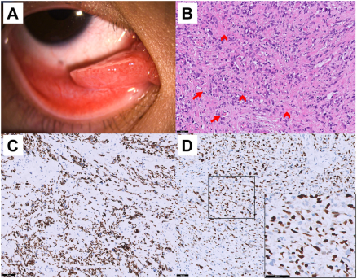

A 13-year-old Asian boy had a fast-growing solid mass on his right lower palpebral conjunctiva and medial canthus for 1 month (A).Magnetic resonance imaging revealed 2 masses in the medial and inferior orbit. Histopathology of the conjunctival tumor showed ovoid andspindled cells with hyperchromatic nuclei and abundant eosinophilic cytoplasm, arranged in a fascicular pattern within hyalinized stroma(arrowheads). Some exhibited a pseudovascular pattern (B, arrows). Immunohistochemical staining results were positive for desman (C)and MyoD1 (D). Molecular analysis revealed an absence of the PAX3/FOXO1 fusion gene. Based on the provided images and clinical description please make an ophthalmic diagnosis for this patient. And output the diagnostic conclusions only.

**Rhabdomyosarcoma.**